[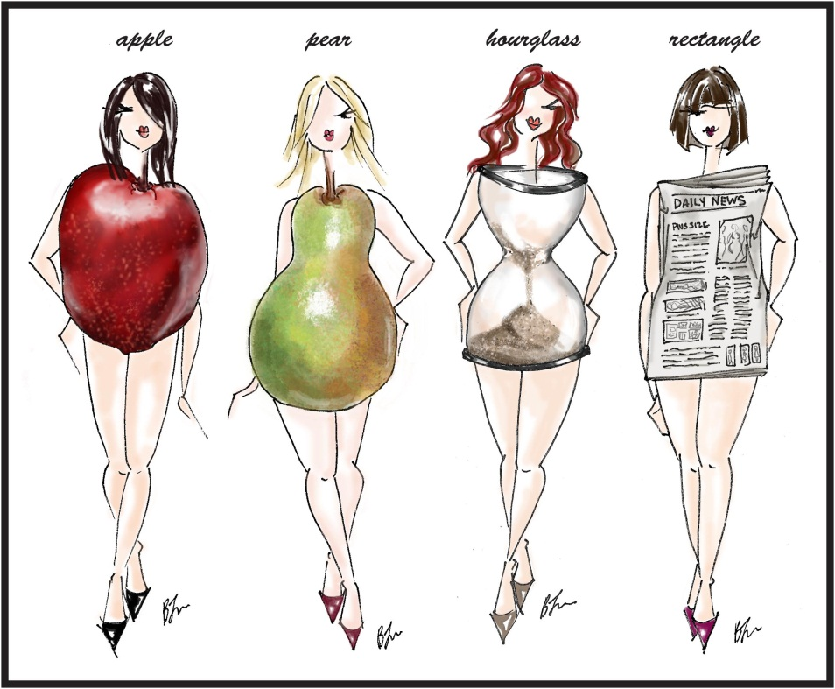](http://www.google.com.au/url?sa=i&rct=j&q=body+image&source=images&cd=&cad=rja&docid=_wjMsaEL-XlqyM&tbnid=Qciqym-zjjYLhM:&ved=0CAUQjRw&url=http://msdianekennedy.wordpress.com/2011/01/04/plus-size-proportions-dressing-for-your-body-type/&ei=O66-UYGZL47jkgX_94GIBw&psig=AFQjCNF5xzGhdFgJCPqqUY8JSQXgpxH9kg&ust=1371537137584511)

Student Name: __________________________________

**Year 8 Health**

**BODY BUSINESS**

**(Body Image Workbook)**

Home Group: ________

**Knowledge Bank**

Each week, record 2-3 things in the table below on what you have learnt from each lesson (this can include new words, new information etc.)

|  |  |
| --- | --- |
| **Week** | **What I have learnt…** |
| 1  Date:__________ |  |
| 2  Date:__________ |  |
| 3  Date:__________ |  |
| 4  Date:__________ |  |
| 5  Date:__________ |  |

You will be required to complete the following worksheets over the term (these will be broken up over the different weeks you have class). When worksheets are completed they will be signed off and dated by your teacher.

**Worksheet Completion**

|  |  |  |
| --- | --- | --- |
| **Worksheet** | **Teacher Signature** | **Date Completed** |
| 1. Collage & reflection |  |  |
| 1. All shapes & sizes |  |  |
| 1. Changing body shape & image |  |  |
| 1. When I am 16 |  |  |
| 1. Media & me |  |  |
| 1. Media messages |  |  |
| 1. HG recording sheet |  |  |
| 1. Analysing media messages |  |  |

**Teacher Comments:**

______________________________________________________________________________________________________________________________________________________________________________________________________________________________________________________________________________________________________________________________________________________________________________________________________________________________

**Overall Mark:**

|  |  |  |  |
| --- | --- | --- | --- |
| **Level** | **7.5** | **8** | **8.5** |
| **Where you’re at** | Half way through year 8 | End of year 8 | Half way through year 9 |

**Collage**

[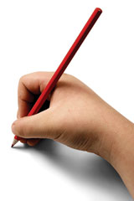](http://www.google.com.au/url?sa=i&rct=j&q=written+reflection&source=images&cd=&cad=rja&docid=jorv1FZhVKJinM&tbnid=CzxEqgXDRHoPLM:&ved=0CAUQjRw&url=http://sydney.edu.au/education_social_work/current_students/assistance_forms/first_year/program_activities.shtml&ei=ZKu-UYXyIYLtkAXv04DIBA&psig=AFQjCNFPwgEdbH-lFArkeuMFr687OI_TyQ&ust=1371536593975492)

**Collage Reflection**

[](http://www.google.com.au/url?sa=i&rct=j&q=&source=images&cd=&cad=rja&docid=4B4g3Z7NEX5OcM&tbnid=xFNDBU2wS2GAhM:&ved=0CAUQjRw&url=http://chughtailab.com/what-personality-type-are-you/&ei=xHm-UfCQLM2ikAXnioCQBA&bvm=bv.47883778,d.dGI&psig=AFQjCNHY7UPuqT38DKZuPEQzUt39kDuXIg&ust=1371523890290234)

* If I had to rate myself on a scale of 1 to 10 for my personality, I would rate myself as a ________

**All Shapes & Sizes**

because __________________________________________________________________________

* If I had to rate myself for my body shape on the same scale, I would rate myself as a _________

because __________________________________________________________________________

* I like my _____________________________ because __________________________________

_________________________________________________________________________________

* I like my _____________________________ because __________________________________

_________________________________________________________________________________

* If I could change just one thing about me it would be __________________________ because

_________________________________________________________________________________

[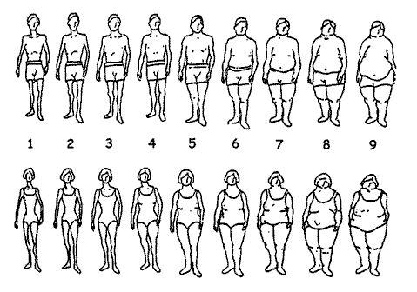](http://www.google.com.au/url?sa=i&rct=j&q=body+shapes+and+sizes&source=images&cd=&cad=rja&docid=7OiEQ56hj0t4QM&tbnid=wWFY02TXt8ZLoM:&ved=0CAUQjRw&url=http://www.halls.md/bmi/figures.htm&ei=rHq-UeXYLMiXkwX7xoDQDg&bvm=bv.47883778,d.dGI&psig=AFQjCNHTleZtKGbamAYaShKheA4sYat6Iw&ust=1371524026076231)

People change the way their bodies look for lots of different reasons. The methods they use to change their body shape are just as varied.

**Changing Body Shape & Image**

Many people go on diets to gain or lose weight. They often find out about these diets from magazines or television. These diets may become part of their daily food routine.

Other people exercise to change the shape of parts of their bodies, e.g. doing sit-ups to make the stomach flatter, using weights to build up muscles.

All people wear clothes. The way people look in clothes varies. Clothes can change the look of a person’s shape. Some people wear baggy clothes to hide their real body shape.

Most people experiment with different hairstyles or hair colour to achieve a different look. Make-up can also be effective in showing off or hiding features of the body.

A number of people now take the option of surgery to remove or add to areas of their bodies. These include facelifts to remove wrinkles and implants to improve body shape.

Changing people’s shapes is a growing area of business. It involves many different types of products and services and is worth millions of dollars.

Fill in the following matrix by placing a √ in the related boxes:

|  |  |  |  |  |  |
| --- | --- | --- | --- | --- | --- |
|  | Hair | Clothes | Diet | Make-up | Surgery |
| Many |  |  |  |  |  |
| Some |  |  |  |  |  |
| Most |  |  |  |  |  |
| All |  |  |  |  |  |

[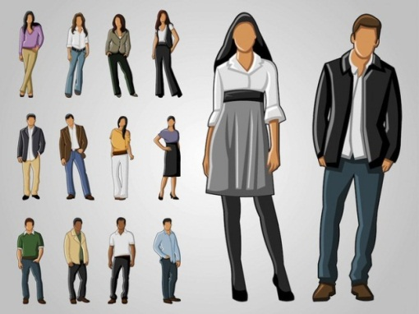](http://www.google.com.au/url?sa=i&rct=j&q=body+image+clothes&source=images&cd=&cad=rja&docid=znezPrn1Qi6HkM&tbnid=Io6pkweeLL2hPM:&ved=0CAUQjRw&url=http://www.freepik.com/free-vector/full-body-fashion-clothes-portraits_681091.htm&ei=uIy-UcHkEYjvlAXOp4GwBw&bvm=bv.47883778,d.dGI&psig=AFQjCNEDoyq5NU1-98ripC9kDvEnr2_QHA&ust=1371528750876447)[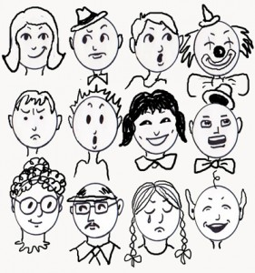](http://www.google.com.au/url?sa=i&rct=j&q=faces&source=images&cd=&cad=rja&docid=fVXcBDhRFGeMZM&tbnid=GbKkGNtVUSI23M:&ved=0CAUQjRw&url=http://drawingfaces.net/the-ways-to-practice-drawing-faces-for-beginners/&ei=34u-UcXYC4vFkwXU7ICQDQ&bvm=bv.47883778,d.dGI&psig=AFQjCNEow0TE2E52yVAg7DC0r33jM_--Ng&ust=1371528511944126)

**When I am 16**

[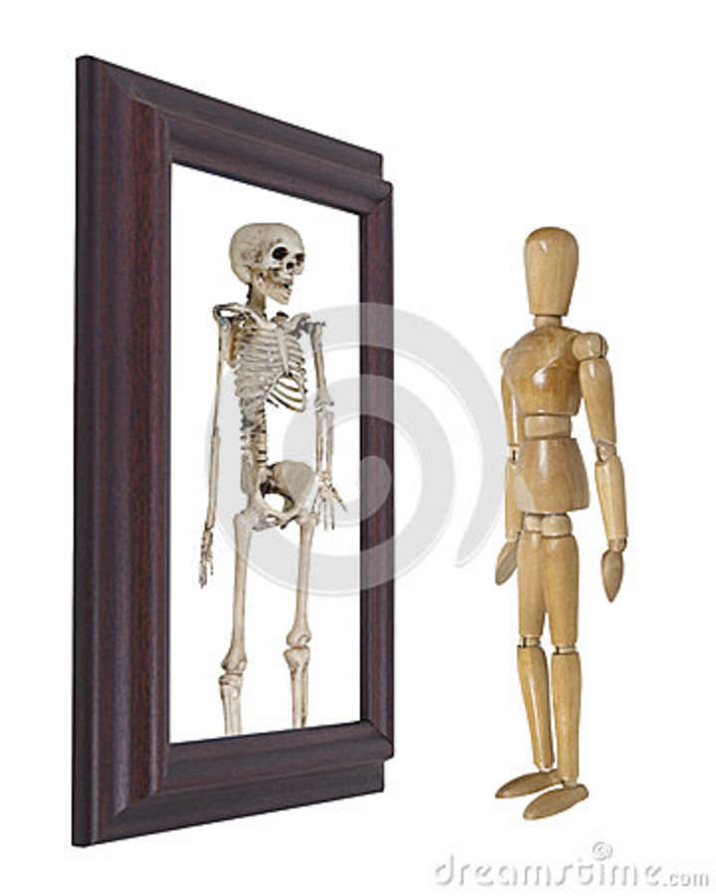](http://www.google.com.au/url?sa=i&rct=j&q=looking+into+the+mirror+-+body+image&source=images&cd=&cad=rja&docid=eo15a6XmNTCSMM&tbnid=GW4r3qHvR7jV5M:&ved=0CAUQjRw&url=http://www.dreamstime.com/royalty-free-stock-photo-model-looking-mirror-seeing-skeleton-image27491795&ei=0o--UZmYGomnlQWH3ICgBw&bvm=bv.47883778,d.dGI&psig=AFQjCNEF6UvFcEbWFSfRR3pShE-_ILJE-w&ust=1371529363977986)

[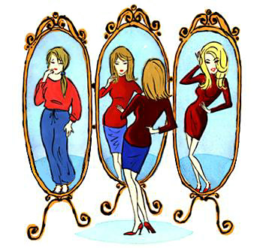](http://www.google.com.au/url?sa=i&rct=j&q=looking+into+the+mirror+-+body+image&source=images&cd=&cad=rja&docid=GGXjeBoZpORE4M&tbnid=0BCANjH7gtjiBM:&ved=0CAUQjRw&url=http://www.inneraltitude.com/blog/?tag=improvement&ei=J4--Ud7PMMq3kgWHyICYAg&bvm=bv.47883778,d.dGI&psig=AFQjCNEF6UvFcEbWFSfRR3pShE-_ILJE-w&ust=1371529363977986)

What do you think you will look like when you are 16?

I know this because _________________________________________________________________

_________________________________________________________________________________

**SURVEY SHEET**

**Media & Me**

|  |  |  |  |  |
| --- | --- | --- | --- | --- |
| Read the question | Circle the closest amount | | | |
| 1. How many movies and videos have you watched in the last two weeks? | 0-1 | 2 | 3 | 4+ |
| 1. How many hours of television have you watched in the last two days? | 0-4 hrs | 5-8 hrs | 9-12 hrs | 13 hrs+ |
| 1. How many magazines/newspapers have you read in the last two weeks? | 0-1 | 2-3 | 4-6 | 7+ |
| 1. How much time have you spent watching music videos in the last two weeks? | 0-1 hr | 2 hrs | 3 hrs | 4 hrs + |
| 1. How much time have you spent playing video games in the last two weeks? | 0-1 hr | 2 hrs | 3 hrs | 4 hrs+ |

1. Which area of the media has had the most influence over you in the last two weeks? (√ in box)

Movies/videos

[](http://powerhomesolutions.blogspot.com/2013/02/commercial-de-cluttering.html)

[](http://www.google.com.au/url?sa=i&rct=j&q=newspaper&source=images&cd=&cad=rja&docid=e1V7eRSE4nb33M&tbnid=sAOsOI1yQl3SFM:&ved=0CAUQjRw&url=http://sec4.edublogs.org/category/newspaper/&ei=jJi-UavEE4ShkAXYmoDQBw&bvm=bv.47883778,d.dGI&psig=AFQjCNE6NhFPZrtTklB5aocPBdUWCCnL3w&ust=1371531558225210) Television

Magazines/newspapers

Music videos

Video games

[](http://www.google.com.au/url?sa=i&rct=j&q=watching+a+movie+in+a+cinema&source=images&cd=&cad=rja&docid=dwHTKprJLgYR5M&tbnid=NCdf4SZ2SqcGFM:&ved=0CAUQjRw&url=http://www.vegelburg.nl/2012/10/rock-solid/&ei=o5S-UbfyGtC_kgXnuYGoBg&bvm=bv.47883778,d.dGI&psig=AFQjCNEfXM0TMAaXvZlN4w8pIVdA0Ce0Kw&ust=1371530737020055)

[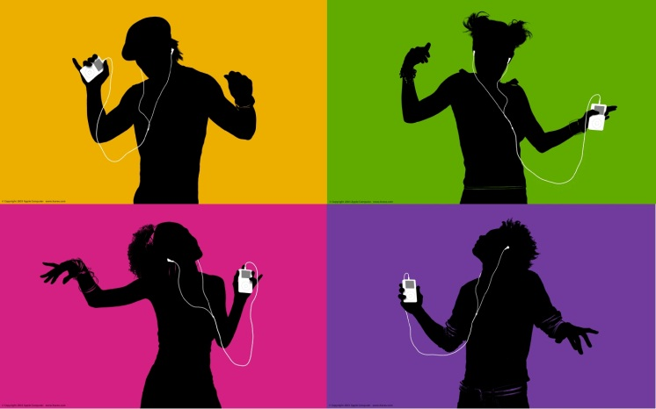](http://www.google.com.au/url?sa=i&rct=j&q=ipod+music&source=images&cd=&cad=rja&docid=X9JSqCOttl2ZiM&tbnid=94jJW9wU5LoHfM:&ved=0CAUQjRw&url=http://hthenning.com/blog/2012/3/19/things-im-thankful-for-music.html&ei=-pm-UefuCIb6kAXJ8YDABw&bvm=bv.47883778,d.dGI&psig=AFQjCNHGbg6a0SaTYvgcyXVpfLJx6MZgDA&ust=1371532117853270)[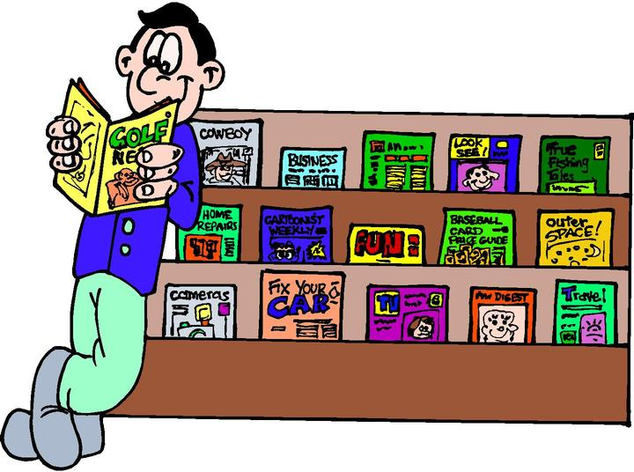](http://www.google.com.au/url?sa=i&rct=j&q=magazines+cartoon&source=images&cd=&cad=rja&docid=LAnuo4bH6j2vUM&tbnid=Y_Kizto7uSejIM:&ved=0CAUQjRw&url=http://waitingonthefrontporch.wordpress.com/2007/07/&ei=Qpe-UcuNE4XRlAWk_YDoAw&bvm=bv.47883778,d.dGI&psig=AFQjCNGa5PhEhuoVFkeKvXbR0Nknv6EIPw&ust=1371531423701353)

Colour Group: __________________________________

**Media Messages**

Question:

__________________________________________________________________________________________________________________________________________________________________

Discussion:

[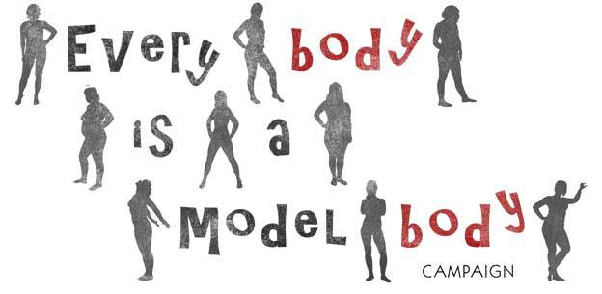](http://www.google.com.au/url?sa=i&rct=j&q=media+messages+about+body+image&source=images&cd=&cad=rja&docid=KVwDxBwfswqEjM&tbnid=UQSlAu4M3QXGDM:&ved=0CAUQjRw&url=http://tracingrealbodymodels.org/category/messages/&ei=Qqi-UdKyEoLOkwXB6YHIBQ&psig=AFQjCNHmqapjNNoXmiCHUAJaRESULNBKWQ&ust=1371535776702232)____________________________________________________________________________________________________________________________________________________________________________________________________________________________________________________________________________________________________________________________________________________________________________________________________________________________________________________________________________________________________________________________________________________________________________________________________________________________________________________________________________________________________________________________________________________________________________________________________________________________________________________________________________________________________________________________________________________________________________________________________________________________________________________________________________________________________________________________________________________________________________________________________________________________________________________________________________________________________________________________________________________________________________________________________________________________________________________________________________________________________________________________________________________________________________________________________________________________________________________________________________________

**Home Group Recording Sheet**

|  |  |
| --- | --- |
| **According to the media, what does the “perfect body” look like?** | **Why would people want to look like the “perfect body”?** |
| **What do you think the term “media messages” means?** | **Why do some people change their body shape to match the media’s ideas about the “perfect body”?** |
| **What other things could people do to make themselves feel good about their body shape instead of changing their body shape?** | **What advice would you give your friends about how to understand media messages about the perfect looking person?** |

**Analysing Media Messages**

Attach advertisement selected below:

[](http://www.google.com.au/url?sa=i&rct=j&q=analysing&source=images&cd=&cad=rja&docid=srvCZVom8InbcM&tbnid=M3EFENUz-QcbVM:&ved=0CAUQjRw&url=http://www.responsetap.com/blog/crafty-adinsight-clarity-features-367&ei=r6O-Ufa-NYqglAXbqoGoCA&bvm=bv.47883778,d.dGI&psig=AFQjCNFmDGurgQFtn2Nj18mqjW0G21eFmg&ust=1371534609231342)

**Analysing Media Messages**

Answer the following questions in the spaces provided in regards to your selected advertisement:

|  |
| --- |
| 1. **Where are you likely to find this advertisement?** |
| 1. **At what group of people is the advertisement aimed at?** |
| 1. **What is the purpose of this advertisement?** |
| 1. **What is happening in the advertisement?** |
| 1. **What language choices have been made to influence the viewer or reader?** |
| 1. **Are there any “hidden messages” in this advertisement? If so, what are they?** |
| 1. **What images are used to give these messages?** |
| 1. **Are the images used in the advertisement real-life images?** |
| 1. **Why do you remember so much about this advertisement?** |

**Appendix**

__________________________________________________________________________________________________________________________________________________________________________________________________________________________________________________________________________________________________________________________________________________________________________________________________________________________________________________________________________________________________________________________________________________________________________________________________________________________________________________________________________________________________________________________________________________________________________________________________________________________________________________________________________________________________________________________________________________________________________________________________________________________________________________________________________________________________________________________________________________________________________________________________________________________________________________________________________________________________________________________________________________________________________________________________________________________________________________________________________________________________________________________________________________________________________________________________________________________________________________________________________________________________________________________________________________________________________________________________________________________________________________________________________________________________________________________________________________________________________________________________________________________________________________________________________________________________________________________________________________________________________________________