NOBLE PARK SECONDARY COLLEGE
CERTIFICATE III SPORT & RECREATION
SISSSCO101

Develop & Update Knowledge of Coaching Practices
(Coaching and Leadership Styles)

“THE GREATEST VICTORIES ARE BORN IN THE HEART”.
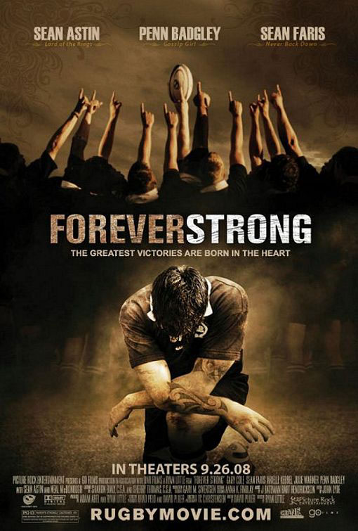
FOREVER STRONG
“THE GREATEST VICTORIES ARE BORN IN THE HEART”.

TASK: Describe Leadership Skills and Responsibilities
Students are to watch Ryan Little’s “Forever Strong”, taking particular notice of the following:
- Leadership styles demonstrated by characters – research.
- Characteristics/qualities of leaders/coaches as demonstrated by key characters.
- Methods used by leaders/coaches to motivate those around them.
- What makes either a good or a poor coach?

QUESTIONS:

- Which characters in the film “Forever Strong” would you categorise as a ‘Leader’?
- List the leadership style, (research), which best describes the reasons for the people listed above being in their position of leadership.
- Using examples from the film, explain the theory of leadership, (research), which are exhibited by the characters listed in question 1.
- How do the characters’ listed in question 1, motivate those around them? Use examples from the film to support your answer.
- How does the coaching style Of the Highland High School Rugby Team’s coach differ from that of the Arizona Rugby Union Team? Which coach generates the best results from their players? – Explain. Why do they achieve the best results?
- From the knowledge gained from the movie and your everyday life, what skills when dealing with people around them, do ‘good’ leaders use?
- Which of the performance criteria identified in the above learning outcomes (4), can either be demonstrated or partially demonstrated through the completion of this worksheet?

